PROJECT DOCUMENTATION

**LESSONS LEARNED LOG**

|  |  |
| --- | --- |
| **Project:** | **Business Management System for Lanka Tools (Pvt) Ltd** |
| Release: | August 2022 |
| Date: | 26th August 2022 |
|  |  |
| **PRINCE2** |  |
|  |  |
| Author: | Bhathiya Kannangara (Project Manager) |
| Owner: | Dr. Yasas Jayaweera (Project Executive) |
| Client: | Lanka Tools (Pvt) Ltd by Mr A.H Athaf |
| Document Ref: | LessonLearnedLog__SmartBMS |
| Version No: | 1.0 |

# 1 Lessons Learned Log History

## 1.1 Document Location

This document is only valid on the day it was printed.

The source of the document will be found on the project's PC in location

## 1.2 Revision History

**Date of this revision:** 08/26/2022

**Date of Next revision:**

|  |  |  |  |
| --- | --- | --- | --- |
| **Revision date** | **Previous revision date** | **Summary of Changes** | **Changes marked** |
| 08/26/2022 |  | First Issue |  |

## 1.3 Approvals

This document requires the following approvals.

Signed approval forms are filed in the Management section of the project files.

|  |  |  |  |  |
| --- | --- | --- | --- | --- |
| **Name** | **Signature** | **Title** | **Date of Issue** | **Version** |
| Dr Yasas Jayaweera |  | Project Executive | 08/26/2022 | 1.0 |
| Bhathiya Kannangara |  | Project Manager | 08/26/2022 | 1.0 |
| Lanka Tools (PVT) Ltd. |  | Client | 08/26/2022 | 1.0 |

## 1.4 Distribution

This document has been distributed to:

|  |  |  |  |
| --- | --- | --- | --- |
| **Name** | **Title** | **Date of Issue** | **Version** |
| Bhathiya Kannangara | Project Manager | 08/26/2022 | 1.0 |
| Imanka Jayasiriwardana | Start-up Manager | 08/26/2022 | 1.0 |
| Uthpala Rajapaksha | Quality Manager | 08/26/2022 | 1.0 |
| Ruwanthi Naramperuma | Risk Manager | 08/26/2022 | 1.0 |
| Layan Perera | Scheduling Manager | 08/26/2022 | 1.0 |

# 2 Table of Contents

Page

1 Lessons Learned Log History 2

1.1 Document Location 2

1.2 Revision History 2

1.3 Approvals 2

1.4 Distribution 2

2 Table of Contents 3

Lessons Learned Log 4

3 Purpose 4

4 Management/Quality Process Assessment 4

5 Deviations 5

6 Method/Tool Performance 5

7 Recommendations 5

8 Measurements of Effort 6

9 Quality/Test Assessment 6

# Lessons Learned Log

## 3 Purpose

This lesson learned document focuses on the lessons the team has learned during the project that will be useful in future projects. The document contains the management framework used, techniques, and methodologies. This document also consists of all the challenges that were faced by each team member as well. This document contains the level of effectiveness or ineffectiveness of the quality and test assessments.

## 4 Management/Quality Process Assessment

The project manager and the quality manager, respectively, were in charge of project management and quality of the both project and the product. A few essential management and quality-control aspects are listed below.

* Before the project commencement, the project manager analysed each team member's capacities, capabilities and allocated roles accordingly.
* Start-up manager coordinate with client and was able to get complete understanding of clients and business requirements.
* Team formed successfully based on the defined roles and meet the deadlines as planned.
* To ensure that team members are working on the most recent versions of the reports and keeping the project board informed of the project's status, all documents have been version controlled using GitHub and Google Drive.
* The system's testing was successfully completed by the quality manager to ensure the Product Quality
* The Risk Manager has been assessed and evaluate all the risks and provided a mitigation plan in order to continue the project without any issue.
* To meet the project's goals and timeline, team members completed all allocated tasks, regardless of their assigned roles.
* Start-up manager and PM scheduled frequent meetings with the client and the project board to update on the project progress. Each week, new features introduced to the system based on the project plan and its functionalities were presented to them for confirmation.
* The project team met with the project supervisor weekly, and the supervisor's feedback helped the team improve critical aspects, including time management, artefact development, and documentation.
* To handle project tasks, the project team used the Jira project management tool. Apart from that, a WhatsApp group was created for members to interact as “SPPM Group 28”.

Team members used online technologies such as WhatsApp and Google Meet to conduct group meetings due to the COVID-19 pandemic as well as travel restrictions due to fuel shortage. The team had to deal with connectivity issues and frequent power interruptions throughout those meetings.

## 5 Deviations

Due of the prevailing global pandemic (COVID-19), we are unable to have meeting with our client face to face frequently. Because of this, we held certain client meetings via online platforms WhatsApp and Google meet, which offered a lower level of comprehension than in-person interactions.

## 6 Method/Tool Performance

From the starting point to the final release, the team members used the PRINCE2 project management method to complete the project. All the required documents were prepared using the PRINCE2 documentation templates provided in BREO. The software tools that the project team used are;

* **Draw.IO**

Draw.IO is an open source web based modelling tool which used to create diagrams such as flowcharts, wireframes, UML diagrams, and Use case and network diagrams.

* **Selenium**

Selenium is a UI testing framework used to run automated tests on a browser. This is used to conduct the quality testing on the system.

* **GitHub**

A repository hosting service used for the purpose of version controlling the documents and the application source Code.

* **XAMMP**

Free and open-source cross-platform web server solution which used to execute server side language PHP.

* **Microsoft Office Package**

Used for the purpose of documentation

## 7 Recommendations

* In order to increase project efficiency, it is crucial to understand each team member's level of expertise in pertinent fields.
* Members should be assigned to project Roles such project manager, start up manager, schedule manager, quality manager, and risk manager after knowing their abilities, capabilities to perform in each tasks productively and correctively.
* Using management tools like Jira in project management could be quite helpful.
* Appropriate communication technology (Google Meet meeting, WhatsApp group call) provide effective and successful communication between the project team members.

## 8 Measurements of Effort

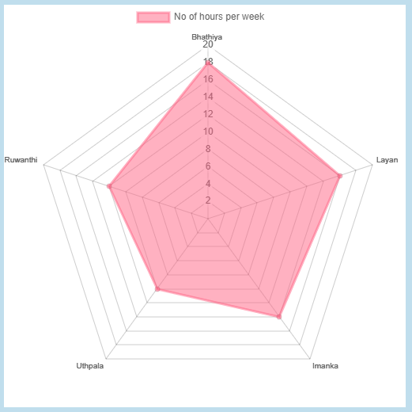

Figure 1: Measurements of Effort

The number of hours each member has spent on completion of the project tasks per Week which used to measure the effort is elaborate on above figure.

## 9 Quality/Test Assessment

Testing is the primary focus of the discovery and investigation stages of the software development process. The testing process ensures that the system meets the needs of the users and the quality of the end product. The results of the testing phase will help the project's minimize the functional and application errors.

Since the project adheres to the Prince2 process, all units generated during the implementation phase merged into the final system following testing. It allows software developers to be subjected to continuous testing to detect mistakes. Following documents were created:

* Quality plan
* Product Quality Check list
* Quality Check list
* Quality Log
* Test Plan
* Issue Log
* Test Cases
* Test Case Scenarios